Feminism in Chinese & Korean Animation
- through <Big Fish & Begonia> and <Yobi, the Five Tailed Fox>

Yiming Zhong, Woosuk Ju, Byungchun Lee

Dept. of Visual Contents, Divison of Digital Contents DSU
Graduate School of Dongseo University, Dongseo University
Busan, South Korea
mr.92est@gmail.com
myeyes71@dongseo.ac.kr

Abstract

Amid active cultural exchange between two leading Asian nations, China and Korea, this paper examines two works of animation, <Big Fish & Begonia> and <Yobi, the Five Tailed Fox>, to analysis the theme of feminism in two aspects; character image and storytelling. It is shown that while there are a number of achievements, there are also shortcomings which conflict with the ideas of feminism. As China-Korea cultural exchange develops, we see an increasing number of Korea-China joint productions of animation. It is hoped that expressions of feminism through character and storytelling, as covered in this study, will inform the product of many more feminist animation works not only in Asia but also all over the world.

Keywords-component; animation; feminism; analysis; Korea-China

I. Introduction

The role of animation goes beyond that of artistic expression to include ideological communication in social context. Many artists convey their thoughts on the society through the medium of animation; indeed, good animations address all matters of society, economy, history and culture. The human, social questions in animation become the very spirit of animation. Feminism began in the late 19th century as a movement for gender equality; it has challenged the male-dominated status quo. From before animation gained its prominence, feminism found its expression in literature, theatre and film. As the feminist movement entered an era of modern feminism (from early 20th century to the 1960s), animation too began to grow rapidly. As such, female characters began to feature as heroes in western animations, such as <Snow White (1947)> and <Alice in Wonderland (1951)>. The western culture, as the origin of feminism, has long been influenced by feminist culture; which is why early feminist animations were all produced in the west. As information technology was limited and Asian nations had a much more conservative outlook, feminism struggled to make its way into Asia; hence there have not been many feminist animations. During the era of post-modern feminism (from the 1960s to the present), many animations in the West began to reflect feminist ideas. Disney, having long produced a series of stereotypical prince-and-princess stories, also began to produce works which messaged female independence, such as <Mulan>, <Brave Heart> and <Frozen>. These excellent works subconsciously propagate the idea of feminism with a global scope. At the same time, we begin to see works of animation with feminist ideas coming out of Asia. This study examines two such works, <Big Fish & Begonia> and <Yobi, the Five Tailed Fox>, from two leading Asian nations. The goal is to analyse character image and storytelling to examine the representation of feminism in those works, contrasting the expressive styles of feminism in two works.

II. Feminism and Animation

A. The Concept of Feminism

Feminism is a social theory and a political movement which originates from and is motivate by women’s experience. While criticising social relations, many supporters of feminism proffer analysis of gender inequality and agenda for promoting women’s rights. Feminist theories seek to explain the essence of inequality, politics and power relations based on gender, and sexuality. The feminist perspective sees that the contemporary society is patriarchal in nature, endowing more rights to men than women. As a grassroots movement which transcends classes and borders, feminist movements in different cultures have come to take different feature; they also promoted different agendas, closely related to local culture. [1]

B .Relating Feminism and Animation

When feminism began to develop in the late 19th century, it used media such as literature and theatre to spread its ideas. As the film industry developed, cinema also became an important tool for feminism. Animation, on the other hand, only began to feature female heroes when feminism entered its modern era (from the early 20th century to the 1960s). Animations with female heroes, represented by Disney’s princess series, were largely welcomed by the public. Although Disney created fantastic princess characters, but they all ended up being saved by a prince, living happily ever after as the prince’s wife. Such stereotypical prince-and-princess love stories reflected the reality of repressed women’s rights; although they were ostensibly animation featuring female heroes, they in fact represented male-led social order. [2] The advent of the era of post-modern feminism coincided with the production of <Mulan (1990)> which in real sense moved out of the traditional prince-and-princess frame to show a courage, free and independent woman; the brave journey of Mulan left a lasting impression, [3] Subsequent animations like <Brave Heart> and <Frozen> also show female heroes struggling to be free and to find their own identity; these works finally echo the feminist ideas. These great animations from the west subconsciously propagate feminism on a global scale. As feminism continues to develop, we have seen feminist-inspired animations coming out of Asia as well. In particular leading Asian nations like China and Korea have produced feminist animations which reflect their own national brands of feminism. Here, <Big Fish & Begonia> of China and <Yobi, the Five Tailed Fox> of Korea were of particular importance, generating debates and great interest, at times even causing controversies.

Ⅲ. Feminism in Chinese & Korean Animation

A. Cases Selection

TABLE I
SYNOPSIS OF THE CASES

Country | Title | Length | Director | Year
China | “Big Fish & Begonia” | 1’45’’ | Liang Xuan  Zhang Chun | 2016
Korea | “Yobi, the Five Tailed Fox” | 1’25’’ | Sunggnag Lee | 2007

B. Feminism in Animation Character Image

The female hero of <Big Fish & Begonia> is called “Choon,” a 16 year-old girl with short hair. She wears traditional Chinese costume and black skirt. Her slim, clean figure without exaggerated makeup represents her pure and innocent spirit. Choon has firm eyes and seldom smiles. Such characterisation creates a firm, simple feminist character in Choon.
The hero of <Yobi, the Five Tailed Fox> is a 10 year-old girl which is in fact a five-tailed fox called Yobi. Her hair resembles fox’s ears and her eyes are not dissimilar to those of a fox; she also has five short, white fox tails. She wears red top and black skirt, an ordinary appearance of a 10 year-old girl. Traditionally, fox is thought to be an alluring and yet sly animal. However, Yobi takes the form of a lovely girl. Here, the author appears to be trying to save Yobi from the stereotypical fox character upon which biases have been built. In fact, the very transition of Yobi into a new, lovely character aligns with the feminist rejection of traditional models of women.

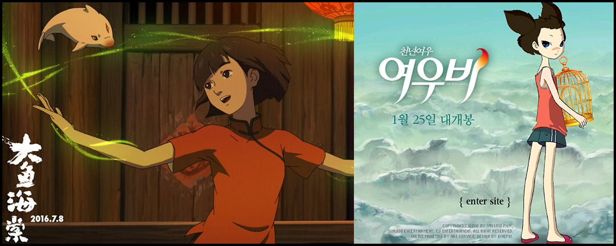

Fig.1 “Choon”&“Yobi”

C. Feminism in Storytelling

TABLE II
FEMINISM IN STORYTELLING

<Big Fish & Begonia> | <Yobi, The Five Tailed Fox >
1. Ideological desire for freedom and escape from the restraints of traditionalcustoms  2. Status and Positional Equality between Women and Men  3. Women’s Responsibility  4. Female perspective on the world | 1.Female compassion and tolerance  2.Escape feudal discriminationagainst women  3. Self-determination  4.Women fight to gain equal rights

In <Big Fish & Begonia>, Choon appears in the first Act in the middle of a rite of passage. Her mother is concerned for Choon who will leave for the human world, but Choon has no fear of the unknown world which she will soon enter; instead, she is full of anticipation and aspirations. Leaving her secret world where she lived for 16 years, she desires to see a new world. Here, Choon’s figure represents the feminist longing for freedom and the ideological desire to escape the chains of traditional customs. Having experienced the human world, Choon goes to the underworld to ask how to save human lives in order to bring Gon, who died because of her, back to life. Youngpa who determines life and death puts forwards all sorts of scary conditions, but Choon remains undeterred. This makes Choon’s character brave and appreciative of love and compassion. Here, what may be seen as a strongly masculine character can be understood as the author’s attempt to equalize male and female roles through Choon. Choon is also characterized for her responsibility. Chhon is clear about her feelings and life; everything she does is motivated by the voice of her own reason. The responsible character which tries to protect others with her power represents women’s value as proposed by feminism – the core of feminism which sees woman in an independent light. [4]
In <Yobi, the Five Tailed Fox>, Yobi faces bullying and insults from her friends; but she treats them not with contempt. Instead she works through difficulties with her benign character and communication with others. When her school bus is involved in an accident, she saves all her classmates. Yobi’s benign character and tolerance is a praise for female virtues. Yobi’s feelings for a male hero put her at a dilemma; is she to live as an ordinary human being? But being a fox, she has to take a human spirit to become a real human being. But she is not controlled by evil spirit; instead, to protect the male hero’s spirit, she sacrifices herself. Yobi, clearly distinguishing good and evil and bravely challenging her fate, represents the feminist calling for women to free themselves from feudal discrimination against women and determine their own fate. In the ending, Yobi finds resurrection thanks to her good character and fulfils her desire to live as an ordinary human being. This is in line with the feminist argument that women must fight to gain equal rights. However, Yobi’s perfect character does take away from the reality of drama. [5]

D. Summary

TABLE Ⅲ
SUMMARY OF THE CASES

Case | Advantage | Disadvantage | Common
<Big fish & Begonia> | - Traditional Chinese background dramatizes the clash between feminism and traditional customs  - Female hero becomes stronger through her struggles | 1.The story excessively depends on the female hero to emphasize the status of women  2.Female hero’s motivation is herself | 1.Female heroes have their own ideals  2.Female heroes have courage and distinctive character  Female heroes long for love  3.Female heroes overcome difficulties to achieve their goals.
<Yobi, The Five Tailed Fox> | - Yobi is freed from the bias and discrimination against the traditional fox character  - Traditional Korean fox mythology has been reinterpreted to complete the character | 1. The story is too simple to convey the significance of women  2. The female character is too perfect to be realistic.

As shown in the table above, two animations have in common that female heroes are brave and with distinctive character; they also achieve their goals through their own efforts. Those are journeys through which female heroes find their ideals; this is a narrative commonly used in feminist animation. Female heroes, as their stories unfold, become feminist characters.

Ⅳ. Conclusion

This study addresses feminist animation through the perspective of character and storytelling. Often female heroes overcome tremendous obstacles to achieve their desires; this narrative depicts a process of development for female characters, in line with the feminist belief that women should aspire to their values. These characters tend to be brave and resolute; hence they live out the feminist ideal of courageous struggle. Romantic affairs of female heroes also form an important story; women who throw everything for love speak for the feminist notion that women can freely seek love. <Big Fish & Begonia> presents a reinterpretation of the rich tradition of mythology and legend in China and Korea, while <Yobi, The Five Tailed Fox> manages to create character image which combines modern design with traditional aesthetics. If future works can draw on their strengths and avoid shortcomings, it would be possible to produce feminist animation to represent Asia. These two feminist animations reflect the cultural characteristics of their respective countries. Through the symbolic representation of feminine ideal in the two feminist animations, a useful insight into female character in Asia and feminist storytelling can be drawn. It is hoped that the present study will serve to inform future China-Korea joint productions which will lead global feminist animation production with public appeal.

References

[1] Hooks, Bell, Feminism is for Everybody: Passionate Politics. Pluto Press. 2000
[2] Wang Shien, The Transformation of Female Character in Disney Animation- A Case Study on Women’s Movement,2012
[3] Nan-ji Hong, A Study of Postfeminism Animation: Focus on Animation of 〈Persepolis〉,2009.9
[4] Liu Xue Jun, The research of animation role design, 2012, 10
[5] Liu Yang, <big fish& Begonia> comment, Radio&TV Journal

